

**Department of Software Engineering**

**Faculty of Computer Science & Information Technology**

**The Superior University, Lahore**

**Name:** MUHAMMAD HAMZA ALI

**Roll No:** SU92-BSAIM-S24-032

**Section:** 3A

**Subject:** ARTIFICIAL INTELLIGENCE(LAB)

**Task No:** Lab-Task 6(Task-1)

**Task-6**

**BFS Without Queue**

**1. Introduction:**

The objective of this task is to implement the Breadth-First Search (BFS) algorithm without using a queue or explicit node data structures. BFS is a fundamental graph traversal technique used for searching and pathfinding.

**2. Features:**

* Represents the graph using a dictionary.
* Uses recursion to simulate level wise traversal.
* Does not use an explicit queue, unlike traditional BFS implementations.
* Prints nodes at each level before recursively processing the next level.
* Demonstrates BFS traversal starting from a given node.

**3. Implementation Details:**

The implementation defines a recursive approach to BFS traversal using a dictionary-based graph representation.

**4. User Interaction:**

* The recursive approach provides an alternative to queue-based BFS but may cause stack overflow for large graphs.
* Unlike traditional BFS, this approach does not explicitly track visited nodes, potentially leading to redundant visits in cyclic graphs.
* For large graphs, an iterative approach using a queue is more efficient in terms of memory usage.

**5. Output:**

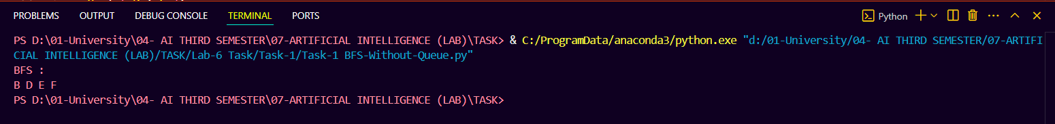

**6. Conclusion:**

This task successfully demonstrates a recursive BFS traversal without using a queue. Future improvements could include cycle detection, iterative implementations, and additional graph-processing features.